“***Creating of Culture of Excellence***”

**Lab Mid Exam**

**Course Title :** System Analysis & Design

**Course Code :** CSE- 325

**Task Name :** (i) Use Case Diagram of a Banking Management System.

(ii) Class Diagram of an Online Shopping System.

**Submitted By:**

**ID : 171442548**

**Name : Md. Habibur Rahaman**

**Program : CSE (Eve)**

**Batch : 44th**

**Date : 20-05-2019**

**Submitted To:**

Supta Richard Philip

Senior Lecturer, Department of CSE

City University, Bangladesh

(i) Use Case Diagram of a Banking Management System.

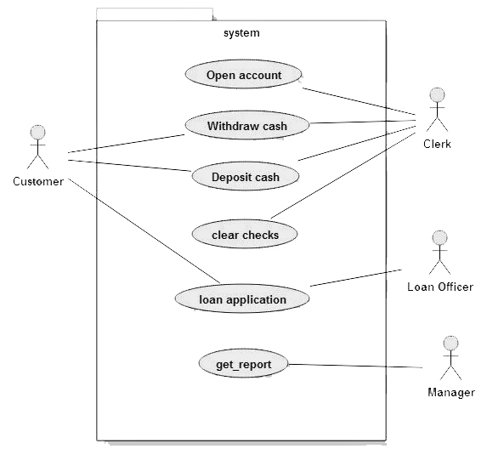

(ii) Class Diagram of an Online Shopping System.

